H.T No
Regulations:
A18

Sreenidhi Institute of Science and Technology
(An Autonomous Institution)
Code No: 7AC07 Date: 20-Jan-2023 (FN)

B.Tech III-Year I- Semester External Examination, January-2023 (Supplementary)
CONTROL SYSTEMS (ECE)

Time: 3 Hours Max.Marks:70

Note: a) No additional answer sheets will be provided.
b) All sub-parts of a question must be answered at one place only, otherwise it will not be valued.
c) Missing data can be assumed suitably.
Bloom's Cognitive Levels of Learning (BCLL)

Remember | L1 | Apply | L3 | Evaluate | L5
Understand | L2 | Analyze | L4 | Create | L6

Part - A Max.Marks:20

Answer all QUESTIONS.

 |  | BCLL | CO(s) | Marks
1 | List the drawbacks of the block diagram reduction technique. | L1 | CO1 | [2M]
2 | Define characteristic equation and order of a system. | L1 | CO2 | [2M]
3 | Write short notes on marginal stability. | L2 | CO3 | [2M]
4 | List the advantages of frequency domain analysis. | L1 | CO4 | [2M]
5 | What is polar plot? | L1 | CO5 | [2M]
6 | What is controllability? What is observability? | L1 | CO6 | [2M]
7 | Define signal flow graph. | L1 | CO1 | [2M]
8 | Write short notes on poles and zeros. | L1 | CO3 | [2M]
9 | State Nyquist stability criterion. | L1 | CO5 | [2M]
10 | Write Masons Gain formula. | L1 | CO4 | [2M]

Part – B Max.Marks:50
ANSWER ANY FIVE QUESTIONS. EACH QUESTION CARRIES 10 MARKS.

 |  |  | BCLL | CO(s) | Marks
11. | a) | Explain Synchro with neat sketch. | L1 | CO1 | [5M]
 | b) | Determine the transfer function X₁(s)/F(s) for the system shown in Fig  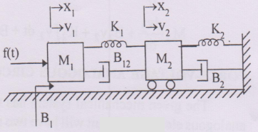 | L2 | CO1 | [5M]
12. | a) | Derive the time response of second order underdamped system due to unit step input. | L3 | CO2 | [5M]
 | b) | For a unity feedback system with open loop transfer function G(s)=50/(1+0.1s)(1+2s), Determine position, velocity and acceleration error constants. | L3 | CO2 | [5M]
13. | a) | Sketch the root locus of the a unity feedback system whose open loop transfer function is G(s)=K/s(s²+6s+10). | L3 | CO3 | [5M]
 | b) | The characteristic polynomial of a system is s⁷+9s⁶+24s⁵+24s⁴+24s³+24s²+23s+15=0. Determine the location of roots on s-plane and hence the stability of the system. | L2 | CO3 | [5M]
14. | a) | Sketch the bode plot for the following transfer function and determine phase margin and gain margin.  G(s)=75(1+0.2s)/s(s²+16s+100). | L5 | CO4 | [5M]
 | b) | Derive the expressions for resonant peak and resonant frequency. | L2 | CO4 | [5M]
15. | a) | The open loop transfer function of a unity feedback system is given by G(s)=1/s (1+s)². Sketch the polar plot and determine the gain margin and phase margin. | L3 | CO5 | [5M]
 | b) | Describe about Lead-Lag compensators design procedure. | L3 | CO5 | [5M]
16. | a) | Calculate the Transfer function of the state model.  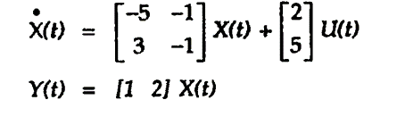 | L3 | CO6 | [5M]
 | b) | Obtain state model of a system whose transfer function is given by  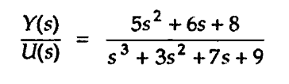 | L5 | CO6 | [5M]
17. | a) | Explain the differences between open loop and closed loop systems. | L2 | CO1 | [4M]
 | b) | Discuss the effects of proportional derivate controller on the performance of the system. | L2 | CO2 | [3M]
 | c) | Explain the RH stability criterion. | L2 | CO3 | [3M]
18. | a) | Define phase crossover frequency, gain crossover frequency and corner frequency. | L1 | CO4 | [4M]
 | b) | What are the three types of compensators? Give their transfer functions. | L1 | CO5 | [3M]
 | c) | Draw the state model of a linear single input- single output system and obtain its corresponding equations. | L2 | CO6 | [3M]

-- 00 -- 00 –

